Submission Details for Chapters in ICTMA Series Books

[Bold Title case regular text 16 pt]
Type the name(s) of the author(s) here [Bold regular text 12 point]
Type affiliation(s) of author(s) here [italics 12 point]
Abstract Send your chapter to book@ictma21.jp no later than November 29, 2023 for a regular paper and December, 29th 2023 for plenaries. Use ICTMA21 in the subject line. Files should be saved in DOCX or DOC format and file names should include the name of the presenting author. For example, a chapter in which Smith is the first author should be saved as Smith.docx or Smith.doc. All chapters must have an abstract which is no longer than 10 lines. The abstract summarises the content and forms part of the 9 pages of the chapter. It starts with the word Abstract in bold on the first line which is completed with text and the entire abstract is left and right justified. [regular text 12 point, space before and after 12 point]
Keywords Include 6 keywords for indexing
- Section [Bold Title case regular text 14 pt] 12 pt space either side
The chapter is to be written in British English using MS Word, Times New Roman, 12- point font, single line space, and 6 points after paragraphs. Please follow this guideline strictly. Use A4 paper size with margins set as follows: top and bottom 3.8 cm; left and right 2.7 cm as in this document. In all text, use the word “chapter” to refer to your submission not “paper”.
The first paragraph under a heading is not indented. All following paragraphs have an indented first line. Footnotes should use 12 point font. They are not to be used for reference citations.Graphics should be inserted at appropriate places in the text at fully readable size. Please do not decrease too much. They need to be readable in the reduced block size of the book, that is a frame of 115 by 180 mm.
  - Sub section [Bold Title case italic text 14 pt] 12pt space either side
Headings: Please use the decimal system of headings with no more than three levels: Example: 1 Section [Bold Title case regular text 14 pt] 12 pt space either side
1.1 Sub section [Bold Title case italic text 14 pt] 12pt space either side
1.1.1 Sub-subsection [Bold Title case regular text 12pt] 12pt space either side
1.1.1 Sub-subsection [Bold Title case regular text 12pt] 12pt space either side
All chapters MUST include an adequate review of the relevant international literature with citations setting your contribution to the field in the context of other modelling work (and your previous work, if relevant). All references should be cited in the text. The author- date method of citation should be used directly in text. The references must use APA style formatting, but with the Springer SocPsych style adaption, which is less rigorous. See Appendix I for Citation and Referencing Styles.
1.1.2 Quotations
Short quotations (less than 40 words) are embedded in the text in regular font, within “quotation marks”. Long quotes (40 words or more) are indented 0.5 cm either side and no quotation marks are used. Use 10 point font. All quotes need source information including author, year, page. Examples: Drakes (2012) also argues that “students would…benefit from modelling done by experts” (p. 12). As an example, Heilio (2013) argues
For successful transfer of mathematical knowledge to client disciplines the theme of mathematical modelling is a crucial mathematical challenge. The lectures, books and laboratory exercises are necessary, but the actual maturing into an expert can only be achieved by ‘treating real patients’. (p. 224)
1.1.3 Sources
If you copy figures or tables from other works, you must obtain permission from the copyright holder for both the print and online format of this book. Enclose the signed permission with the manuscript. Some publishers do not grant electronic rights for free. Springer will not be able to refund any costs incurred in receiving these permissions. As an alternative, material from a different source should be used that grants permission. The source must be acknowledged in the figure caption or table heading. Sources in a language other than English should be translated.
1.1.4 Transcripts
Transcripts are in 12 point, regular font with no quotation marks with 6 point before the beginning of a transcript and 6 points after the end of the entire transcript.
Jim: Sine over?
Ozzie: No the angle not the [stops]. It’s like reverse.
Ahmed: Sin?
Jim: I remember it’s reverse. You do that full stop. Yeah, you do the one on top [pointing to tan⁻¹ on his graphing calculator].
1.2 Figures, diagrams, tables, equations, literal texts, tasks
1.2.1 Figure and Diagrams
These must be clearly readable (i.e., the point size must be large enough to see every piece of text clearly) and clearly able to be reproduced in black and white, not colour. Figures must be referred to in the text (e.g., see Fig. 2.4.). At the start of a sentence use Figure 2.4 but Fig. 2.4 elsewhere.
・When preparing your figures, the figures should be: 78 mm or 117 mm wide and not higher than 198 mm.
・Number figures consecutively using the chapter number (e.g., Fig. 1.1). All figure parts should be denoted by bold lowercase letters (a, b, c, etc.). You can group 3 smaller figures with named parts in a 117 mm wide figure.
・Each figure should have a concise caption describing accurately what the figure depicts. Include the captions in the text file of the manuscript, not as part of the figure file.
・Figure captions begin with the term Fig. in bold type, followed by the figure number in bold type.
・No punctuation is to be included after the figure number, nor the end of the caption.
・Identify all elements found in the figure in the figure caption; and use rectangles, circles, etc., as coordinate points in graphs.
・Identify previously published material by giving the original source in the form of a citation at the end of the figure caption.
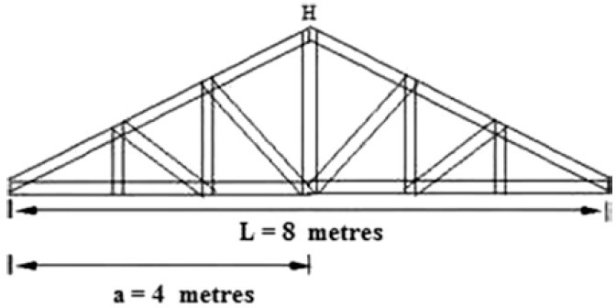
Example Figure 78 mm wide:
Fig. 13.1 Scheme of a gable used in Brazilian roof constructions

Example Figure 117 mm wide:
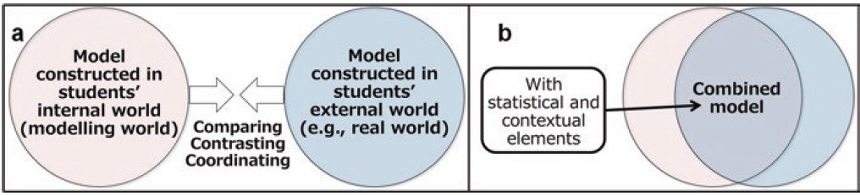
Fig. 8.1(a) Conceptualisation of combining models (b) Conceptualisation of combined models

1.2.2 Figure and Diagrams:
These are numbered consecutively using the chapter number (e.g., Table 1.1). So, ensure all the tables are numbered consecutively and cited in the text in the correct order. Give each table a heading. To format the table columns, use the table function. Do not use the space bar to separate columns, and do not use Excel to create tables. Make sure you make your tables so they fit in the text block when printed. Very large tables are sometimes printed vertically on a separate page reducing your available space. Please use 11 point character size within the table.

Example Table 1
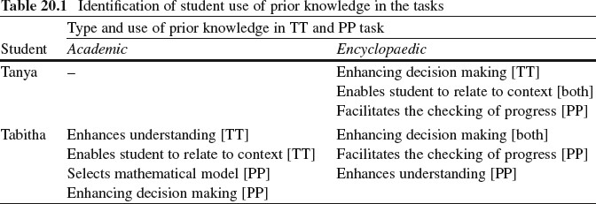
Example Table 2
Table 1.1 Mean numbers of correct (C), proportional (P), and other (O) answers on three problems
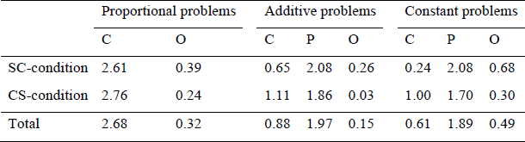
Table notes should be used at the foot of the table in 10 point beginning with “Note.” These should be listed on separate lines in the following sequence: General comments referring to entire table, Explanations of abbreviations in a run-in list and Asterisk(s) (p values), followed by any column, row or cell specific notes using superscript lowercase letters (i.e., ^{a,} ^{b,} ^{c}).
1.2.3 NOTE:
Use column headers of the same size as this will determine the spacing of the numerical data in your columns (e.g., using Strongly Agree, Agree, Disagree and Strongly Disagree will result in widely different spacing and the copy editors will not change this.)
For text tables the cells are set up with hanging indents if the content is more than one line. This will be done by the copy editors. Refer to Tables by number (e.g., in Table 2.1) not expressions such as “in the Table below”.
1.2.4 Tasks or Problems:
If presenting a task used in a classroom or study, present within a borderless rectangular box with grey shading. When referring to the task use italics on the title, for example, The Man With The Golden Gun Task.
1.2.5 Equations
Equations of the type a² + b² = c² can be written as normal text. Use italics as shown and a space before and after each term or symbol as necessary. For all other equations, use the Microsoft equation editor for the whole equation.
1.2.6 Literal Text
In order to distinguish literal text of computer programs, we recommend using a font such as Arial or Helvetica. If you need a font for your programs in which every character has the same width, use Courier.
2 Spelling, Punctuation and Expression
Please note the following terms, spelling: “modelling” and abbreviations (when inside parentheses) “e.g.,”, “i.e.,” “student”. Use “mathematics” not “math” or “maths”, “examination” not “exam”, “modelling” and “mathematics” should not have an upper case “M”. Reduce use of capitalisation to a minimum. Use better expression than “get”.
2.1 Abbreviations:
Write abbreviations in full if in text but abbreviate when in parentheses, for example, “modelling tasks (e.g., the Ferris Wheel)”. Exception: use (See Fig. 2.1) instead of (s. Fig. 2.1). Minimise use of abbreviations.
2.2 Acknowledgements:
These should be in 10 point and come after the chapter concludes but before the references.
References
Brady, C. (2018). Modelling and the representational imagination. ZDM-Mathematics Education, 50(1–2), 45–59.
Brown, J. P. (2015). Complexities of digital technology use and the teaching and learning of function.
Computers & Education, 87, 112-122.
Baker, C.K., & Galanti, T.M. (2017). Integrating STEM in elementary classrooms using model-eliciting activities: responsive professional development for mathematics coaches and teachers. International Journal of STEM Education, 4(1): 10. doi: 10.1186/s40594-017-0066-3
Greefrath, G., & K. Vorhölter. Teaching and learning mathematical modelling: Approaches and developments from German speaking countries, ICME-13 topical surveys. Springer Open.
Stillman, G.A., Blum, W., & Kaiser, G. (Eds.). (2017). Mathematical modelling and applications: Crossing and researching boundaries in mathematics education. Cham: Springer.
Bliss, K.M., Galluzzo, B.J., Kavanagh, K.R., & Levy, R.. (2018). Visualization. In Math modelling: Computing & communicating (pp. 39-56). Philadelphia: Society for Industrial and Applied Mathematics.
Stake, R. (2005). Qualitative case studies. In N. Denzin & Y. Lincoln (Eds.), The Sage handbook of qualitative research (3rd ed., pp. 443–466). Sage.
Stender, P., Krosanke, N., & Kaiser, G. (2017). Scaffolding complex modelling processes. In G.A. Stillman,
W., Blum, & G. Kaiser (Eds.). (2017). Mathematical modelling and applications: Crossing and researching boundaries in mathematics education (pp. 467-477). Springer.
Stillman, G.A. (2019). State of the art. On modelling in mathematics education—Lines of inquiry. In G.A. Stillman, & J. P. Brown (Eds.), Lines of inquiry in mathematical modelling research in education (pp. 1– 20). Springer Open.
Siller, H._S., & Greefrath, G. (2010). Mathematical modelling in class regarding to technology. In V. Durand- Guerrier, S. Soury-Lavergne, & F. Arzarello (Eds.), Proceedings of CERME 6 (pp. 2136–2145). Lyon: INRP.
Green, G. (2009, January 14). Big cat discovery casts little doubt. The Courier Mail, p. 17.
Kaiser, G., Sriraman, B., Blomhøj, M., & Garcia, J. (2007). Report from the CERME5 working group modelling and applications – Differentiating perspectives and delineating commonalties. ICTMA Newsletter, 1(1), 6–10.
Organisation for the Promotion of Responsible Tuna Fisheries. (2006). A graph of fish catches of Bluefintuna. http://www.oprt.or.jp/c27.htm Accessed 22 Feb 2013.
Scott-Wilson, R. (2014). An analysis of learning characteristics, processes and representations in mathematical modelling of middle school learners with special educational needs (Doctor of Philosophy thesis). Stellenbosch University, Cape Town, South Africa.

APPENDIX I Citation and References styles
All chapters MUST include an adequate review of the relevant international literature with citations setting your contribution to the field in the context of other work (and your previous work, if relevant).
Citations
All references should be cited in the text. The author-date method of citation should be used directly in text.
Example:
Ärlebäck and Bergsten (2010) used an analytical tool, a modelling activity diagram, to analyse students’ productions when they faced Fermi problems. Ärlebäck (2011) states that working with Fermi problems may be useful for introducing modelling into classrooms…
For author name/s and year of publication in parentheses: one author (D’Ambrosio 2015),
two authors (Durandt and Jacobs 2017), three or more (Zubi et al. 2019);
References not cited must be removed.
When referring to multiple authors, list these alphabetically on first author not date (e.g., Ang 2013; Blum 2007; Stillman et al. 2009).
Reference List: Each chapter must contain a reference list headed "References". This heading is not numbered. Entries in the list must be listed alphabetically. The rules for alphabetisation are:
- all works by the author alone, ordered chronologically by year of publication,
- next, all works by the author with a co-author, ordered alphabetically by co-author,
- then, works by the author with several co-authors, ordered by increasing publication year.
The references must use APA style formatting, but with the Springer SocPsych style adaption, which is less rigorous. ALL details need to be included by you.
Journal article
Brady, C. (2018). Modelling and the representational imagination. ZDM-Mathematics Education, 50(1–2), 45–59.
Brown, J. P. (2015). Complexities of digital technology use and the teaching and learning of function.
Computers & Education, 87, 112-122.
Journal article only by DOI
Baker, C.K., & Galanti, T.M. (2017). Integrating STEM in elementary classrooms using model-eliciting activities: responsive professional development for mathematics coaches and teachers. International Journal of STEM Education, 4(1): 10. doi: 10.1186/s40594-017-0066-3
Book
Greefrath, G., & K. Vorhölter. Teaching and learning mathematical modelling: Approaches and developments from German speaking countries, ICME-13 topical surveys. Springer Open.
Stillman, G.A., Blum, W., & Kaiser, G. (Eds.). (2017). Mathematical modelling and applications: Crossing

and researching boundaries in mathematics education. Cham: Springer.
Book chapter
Bliss, K.M., Galluzzo, B.J., Kavanagh, K.R., & Levy, R.. (2018). Visualization. In Math modelling: Computing & communicating (pp. 39-56). Philadelphia: Society for Industrial and Applied Mathematics.
Stake, R. (2005). Qualitative case studies. In N. Denzin & Y. Lincoln (Eds.), The Sage handbook of qualitative research (3rd ed., pp. 443–466). Sage.
Stender, P., Krosanke, N., & Kaiser, G. (2017). Scaffolding complex modelling processes. In G.A. Stillman,
W., Blum, & G. Kaiser (Eds.). (2017). Mathematical modelling and applications: Crossing and researching boundaries in mathematics education (pp. 467-477). Springer.
Stillman, G.A. (2019). State of the art. On modelling in mathematics education—Lines of inquiry. In G.A. Stillman, & J. P. Brown (Eds.), Lines of inquiry in mathematical modelling research in education (pp. 1– 20). Springer Open.
Conference Paper
Siller, H._S., & Greefrath, G. (2010). Mathematical modelling in class regarding to technology. In V. Durand- Guerrier, S. Soury-Lavergne, & F. Arzarello (Eds.), Proceedings of CERME 6 (pp. 2136–2145). Lyon: INRP.
Newspaper Article
Green, G. (2009, January 14). Big cat discovery casts little doubt. The Courier Mail, p. 17.
Newsletters
Kaiser, G., Sriraman, B., Blomhøj, M., & Garcia, J. (2007). Report from the CERME5 working group modelling and applications – Differentiating perspectives and delineating commonalties. ICTMA Newsletter, 1(1), 6–10.
Online Document (no DOI available)
Organisation for the Promotion of Responsible Tuna Fisheries. (2006). A graph of fish catches of Bluefin tuna. http://www.oprt.or.jp/c27.htm Accessed 22 Feb 2013.
Theses and Dissertations
Scott-Wilson, R. (2014). An analysis of learning characteristics, processes and representations in mathematical modelling of middle school learners with special educational needs (Doctor of Philosophy thesis). Stellenbosch University, Cape Town, South Africa.

Appendix II: METADATA (to be submitted with first draft of chapter) Chapter Title:
For the corresponding Author:

Given Name Department Institution/Organisation
Address (full postal address not a PO Box number) Email

For each additional Co-Author:

Family Name Given Name Department
Institution/Organisation
Address (full postal address not a PO Box number) Email

Abstract (10 lines only with NO citations)

Keywords (at least 6 for indexing see previous books in series)

Originality: [To be signed by ALL authors.]
We hereby certify that this chapter is not being submitted for consideration for publication elsewhere and is original, unpublished work:

Checklist (for author use only – not to be submitted)

Metadata | Title | 7
 | Name(s) of author(s) | 7
 | Complete Mailing address(es) | 7
 | e-mail address(es) | 7
 | Keywords | 7
Headings | Decimal numbers | 7
Abstract | Abstract for chapter included (10 lines, no citations) | 7
Text | Text in Times New Roman, special characters in Symbol or Unicode | 7
References | Reference lists included at the end of chapter | 7
 | Citations in text agree with the reference list | 7
 | All entries in the reference list mentioned in the text | 7
 | References complete and follow the guidelines | 7

Abbreviations Author abbreviations follow only after first time use written in full. Use sparingly. 7
Figures All figures mentioned in text and complete 7
Consecutively numbered within a chapter 7
Consecutively cited in text 7
Legends included in the text 7
Clearly readable in black and white 7
Tables Prepared with the table function 7
Consecutively numbered within a chapter 7
Consecutively cited in text 7
Electronic manuscript Used file name format with current date of submission 7
Files saved as Word files 7
Each chapter saved as separate file 7
Graphics saved as separate files in original format and in Jpeg, EPS or TIFF format 7

