 Newsletter Volume 8 Number 1 August 2015

The International Community of Teachers of Mathematical Modelling and Applications.
www.ictma15.edu.au
The Community, through its membership, research and other activities, is recognised as "The International Study Group for Mathematical Modelling and Applications (ICTMA)" by its affiliation to the International Commission on Mathematical Instruction (ICMI).

Editor  Associate Professor Gloria STILLMAN  Faculty of Education and Arts  Ballarat Campus  Australian Catholic University, AUSTRALIA  Email: gloria.stillman@acu.edu.au | President  Associate Professor Gloria STILLMAN  Faculty of Education and Arts  Ballarat Campus  Australian Catholic University, AUSTRALIA  Email: gloria.stillman@acu.edu.au

Contents
1. International Executive Committee 2
2. Report from latest Conference – ICTMA 17 2
3. Forthcoming ICTMA Conference – ICTMA 18 4
4. Bids to hold Upcoming Conference – ICTMA 19 5
5. Brief News Items 5
6. Recent Dissertations 6
7. Publications of Interest 9
8. Problems Section 12
Please send future contributions to the editor by email <gloria.stillman@acu.edu.au>. The next Newsletter will be published in December, 2015. We are interested in your contributions to any of the current sections including project reports and problems.
Website
Owing to government action beyond our control the ICTMA website was removed. Jill Brown is in the process of restoring links and files that were on the previous website so if any of these files which are currently showing as broken links were contributed by you could you please send to jill.brown@acu.edu.au The site is currently working through the former site for ICTMA15. Please note the URL above. We are also restoring and cleaning up the email list so please help us update your information and remove the large number of bouncing email addresses.
1. International Executive Committee
Following the business meeting of ICTMA members held at ICTMA 17 in Nottingham, England, on July 24, 2015, the ICTMA Executive for 2015-2017 was confirmed as follows:

President
Prof Gloria Stillman (Australia) – Newsletter Editor [Email: gloria.stillman@acu.edu.au]
Elected Members
Dr Jill Brown (Australia) – Secretary, Webmaster & List Serve Moderator [Email: Jill.Brown@acu.edu.au]
A/Prof Susana Carreira (Portugal) – [Email: scarrei@ualg.pt]
Prof Dr Gabriele Kaiser (Germany) [Email: gabriele.kaiser@uni-hamburg.de]
Co-opted Members
A/Prof Angeles Dominguez (Mexico) [Email: angeles.dominguez@itesm.mx]
Prof Toshikazu Ikeda (Japan) – Registrar [Email: ikeda@ynu.ac.jp]
Prof Jinxing Xie (China) [Email: jxie@math.tsinghua.edu.cn]
Conference Organisers
Prof Maria Salett Biembengut (Brazil) [Email: mariasalettb@gmail.com]
A/Prof Geoff Wake (UK) [Email: Geoffrey.Wake@nottingham.ac.uk]
Dr Helena Wessels (South Africa) [Email: helena.wessels6@gmail.com]

2. Report from Latest Conference – ICTMA 17
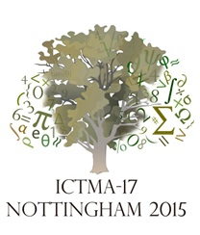
17th International Conference on the Teaching of Mathematical Modelling and Applications (ICTMA17) 19-24 July 2015
Conference Theme: Modelling Perspectives: Looking in and across boundaries.
The Centre for Research in Mathematics Education (CRME), University of Nottingham, U.K., hosted the 17th International Conference of the Community of Teachers of Mathematical Modelling and Applications from 19-24 July. Associate Professor Geoff Wake was Conference Chair. The conference was organised by CRME staff, with the Conference Chair being supported by Professors Hugh Burkhardt and Malcolm Swan (Director of CRME), University of Nottingham. The local organising team included Phill Rostron, Sheila Evans, Marc North, Leonardo Barichello, and Rita Guimaraes. | 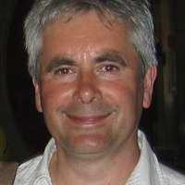
The Conference theme was Modelling perspectives: Looking in and across boundaries. It was intended to provide a stimulus to consider new approaches drawing on best practice from other related research in mathematics education and associated domains. Inspiring plenaries were given by:
Associate Professor Keiichi Nishimura, Gakugei University, Tokyo – Japan’s Ongoing Reform in Maths: Will Modelling Help? [Response by Morten Blomhøj, Denmark]
Professor David Burghes, Plymouth University, UK – Mathematical Modelling: Its Role to Enhance Mathematical Pedagogy? [Response by Gloria Stillman, Australia]
Dr Peter Frejd, Linköping, Sweden – Mathematical Modelling as a Profesional Activity – Lessons for the Classroom [Response by Gabriele Kaiser, Germany]
Prof. Malcolm Swan and Prof Hugh Burkhardt, University of Nottingham, UK – Systemic change and Teaching Modelling [Response by Katja Maaß, Germany]
The power point presentations of the plenary speakers will be available from the website.
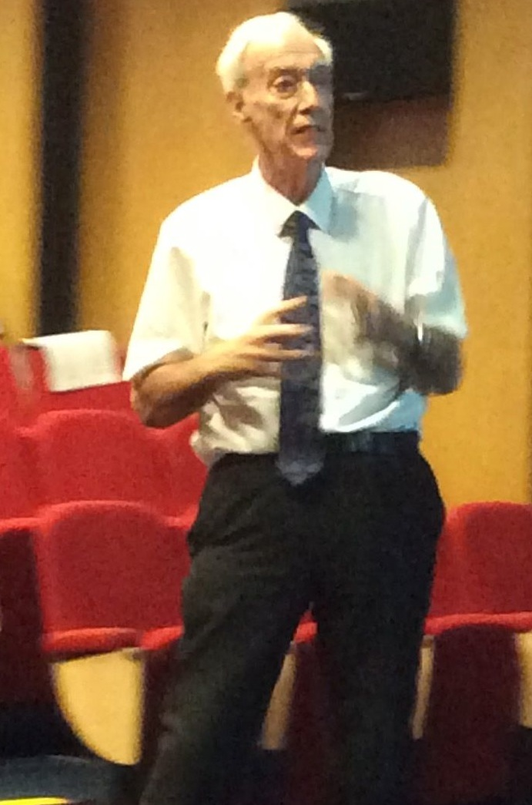 | 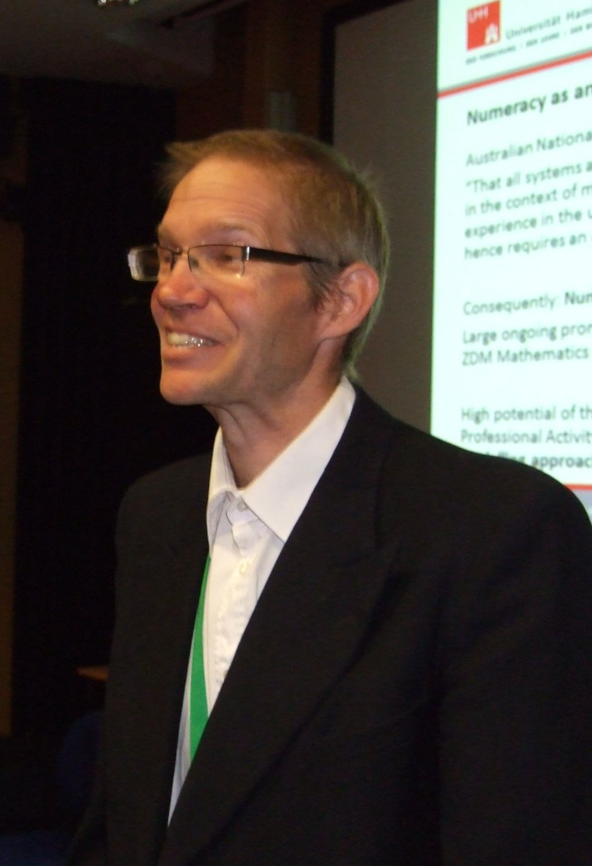 | 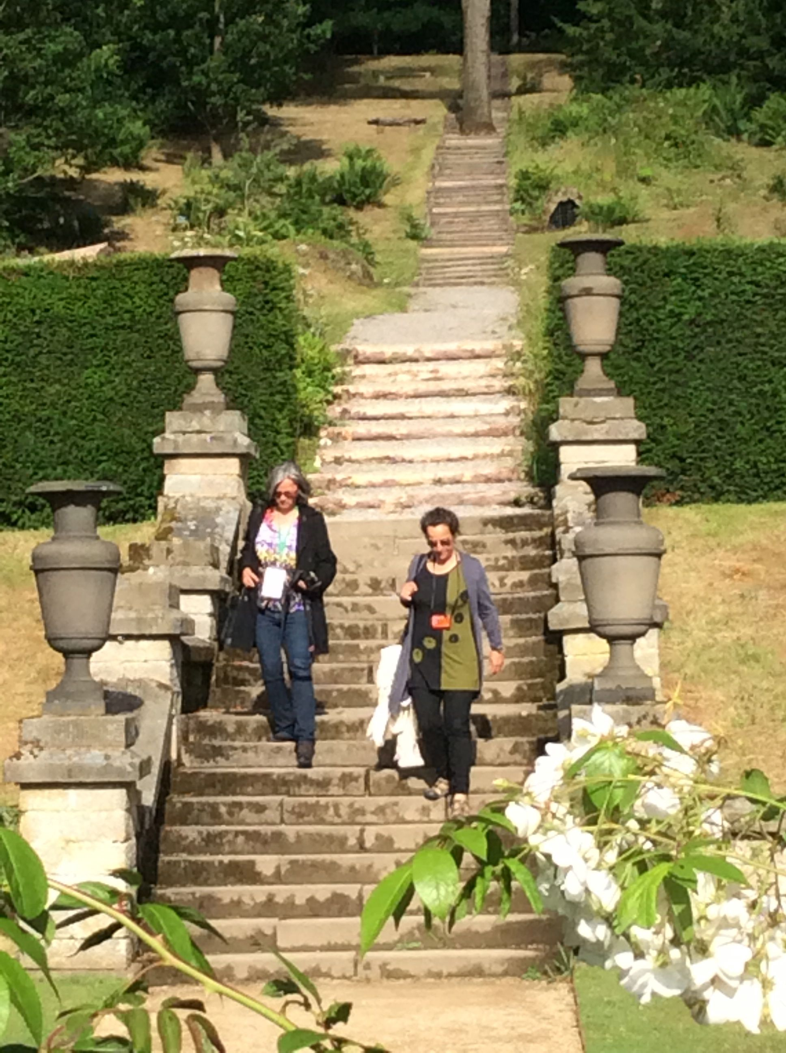 | 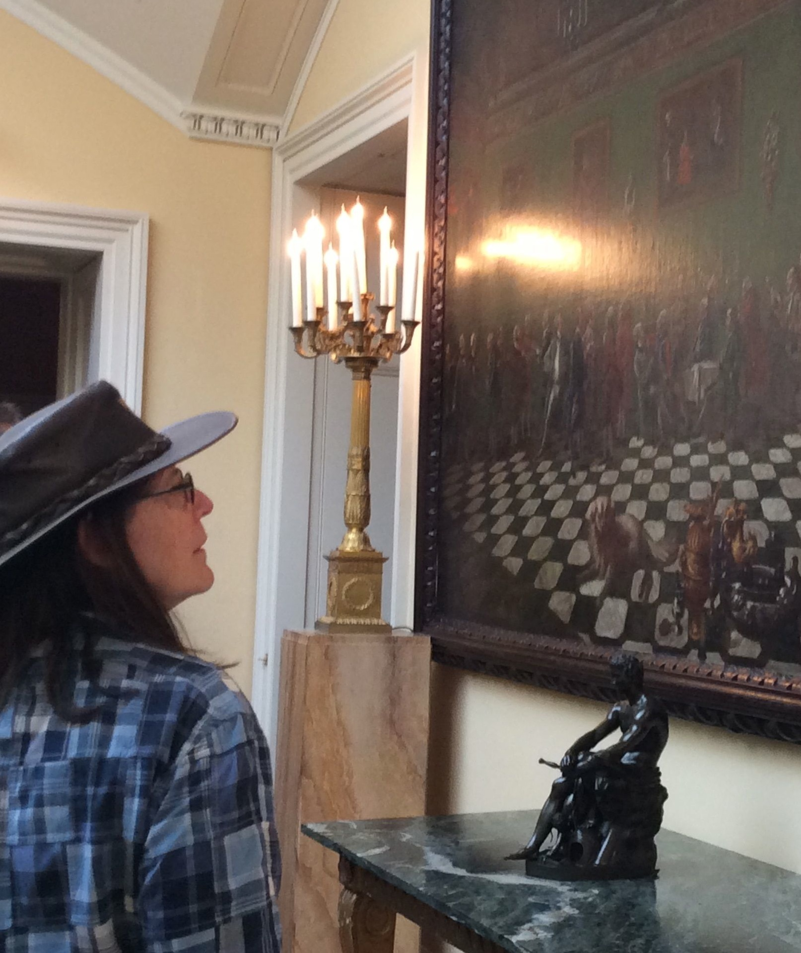
Prof David Burghes (UK) | Peter Frejd (Sweden) | Excursion to Cavendish House
A plenary panel chaired by Prof Werner Blum (Germany), comprising Helen Doerr (USA), Dr Angeles Dominguez (Mexico), A/Prof Vince Geiger (Australia), Prof Pauline Vos (Norway) and Dr Helena Wessels (South Africa) addressed the theme: Modelling in Curricula across the World. There were also paper presentations related to research, theory, and practice and poster presentation sessions. In addition, editors Gloria Stillman and Werner Blum gave a plenary presentation on Writing for Books in the ICTMA Series. This presentation also included Bookmetrix data which confirms the high visibility of our work internationally. The powerpoint presentation is available from the ICTMA website. One hundred and three parallel lecture presentations were given. There were 140 participants who came from 23 different countries. The largest representation was from the UK (26) but there were also large contingents from Germany (20) and Japan (17).
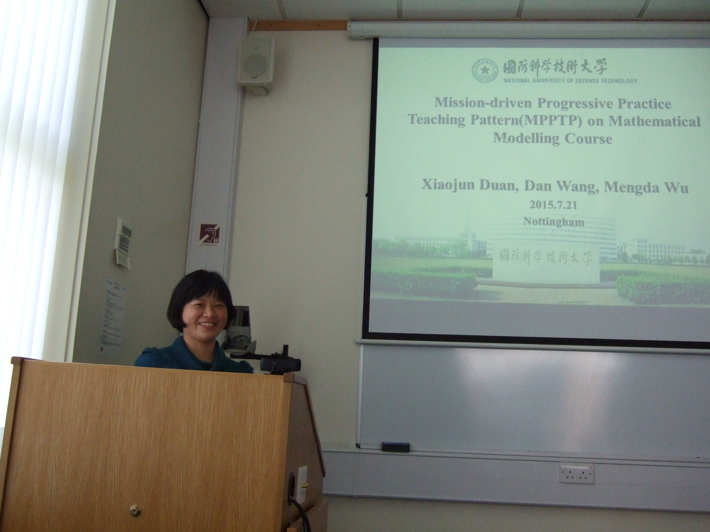 | 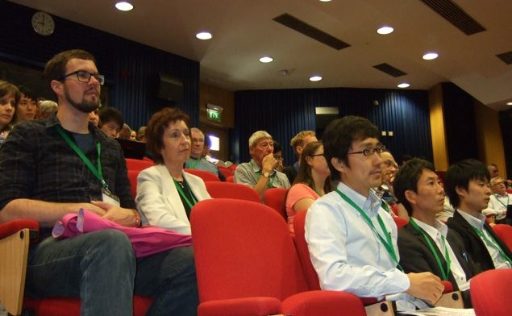 | 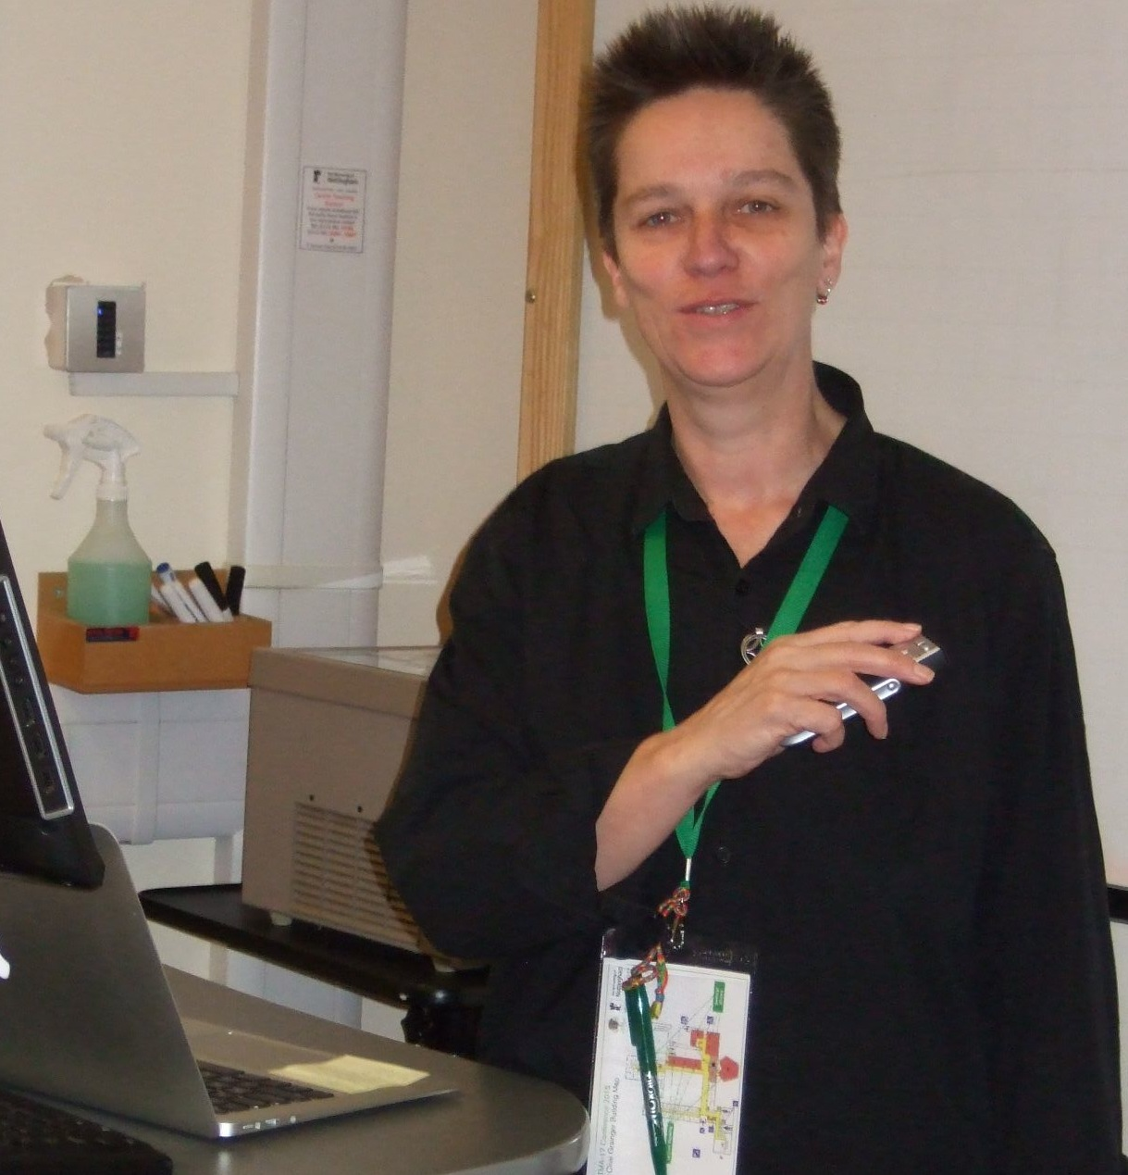
Xiaojun Duan (China) | Audience at Opening of ICTMA 17 | Jill Brown (Australia)
At the business meeting at the end of the conference, paper presenters at the conference were invited to submit a book chapter for a proposed new book in the ICTMA series to be published by Springer in their series, International Perspectives on the Teaching and Learning of Mathematical Modelling. The editors for the book are Geoff Wake, Gloria Stillman, Werner Blum and Marc North. The working title is Crossing and Researching Boundaries in Mathematical Modelling Education. See ICTMA website for links to more recent book details. Proposed chapters from regular presentations are due by September 15, 2015. Chapters from plenary presentations are due November 15, 2015. Only a selection of these proposed chapters will be published after a strict reviewing process to ensure a high standard of scholarship and scientific quality. The minutes from the business meeting are on the ICTMA website.
The conference was held in the excellent academic facilities of the Sir Clive Granger Building in The University of Nottingham’s University Park campus. University Park is Nottingham’s largest campus at 300 acres. Part of the University since 1929, the campus is widely regarded as one of the largest and most attractive in the country. It is conveniently located only two miles from the city centre. The social program included an opening reception at Highfields House, drinks reception hosted by the Shell Centre, an excursion to Chatsworth House and the conference dinner at Colwick Hall.
Conference Website www.nottingham.ac.uk/ICTMA17

3. Forthcoming Conference – ICTMA 18
18th International Conference on the Teaching of Mathematical Modelling and Applications (ICTMA18) 2017
Theme: Mathematical Modelling and Sense Making
The Research Unit for Mathematics Education at the University of Stellenbosch (RUMEUS), Cape Town, South Africa, supported by the Mathematics and Mathematics Education bodies in South Africa (SANCIMU, SAMF, SAMS and AMESA), has been selected to host the next International Conference for the Teaching of Mathematics and Applications (ICTMA 18) in July 2017. The Steering Committee consists of members of RUMEUS, that is Dr Helena Wessels (Member and Conference Chair: ICTMA18), Prof Dirk Wessels (Director), and Dr Erna Lampen, Dr Faaiz Gierdien and Mr Cerenus Pfeiffer from the Centre for Education Pedagogy (SUNCEP) as members.
Venue
The conference venue is Cape Town Lodge Hotel and Conference Centre (visit www.capetownlodge.co.za for further details). It is located at 101 Buitengracht Street, Cape Town. It is thus located in the city’s business centre and is only 20 minutes from Cape Town’s International Airport. Mycity bus provides international visitors with a service between the city centre and the airport.
Visas
Visas are issued by the South African missions abroad and must be affixed in the applicant’s passport before departing for South Africa. Visas are not issued on arrival at South African ports on entry. Many nationalities do not require a visa to enter South Africa, it is best to check with your travel agents if this is enquired. For detailed information, please visit:
http://www.ser vices.gov.za/services/content/Home/ServicesforForeignNationals/Temporaryresidence/
Applicationforavisa/en_ZA
Currency
The Rand is the official currency of South Africa.
Travel
Cape Town International Airport is served by more than 20 international airlines on a weekly basis, linking the destination to global hubs like Frankfurt, Amsterdam, Dubai, Singapore and London (and a wide variety of other connections via Johannesburg). The city is an overnight flight from any European destination.

4. Bids to hold Upcoming Conference – ICTMA 19
19th International Conference on the Teaching of Mathematical Modelling and Applications (ICTMA19) 2019
Any groups considering hosting ICTMA 19 in 2019 are invited to send a written Expression of Interest to the President who will then send details of the requirements for a full bid. Full bids to host the conference in the form of a bidding book and supporting letters will be due in June 2017. It is best though to start working well before this to make a comprehensive proposal.

5. Brief News Items
5.1 CERME 9: Thematic Working Group 6
Applications and Modelling was well represented in a thematic working group at the ninth Congress of European Research in Mathematics Education (CERME 9) held 4-8 February at Charles University in Prague, Czech Republic. The leaders included ICTMA members Susana Carreira (Portugal), Gabriele Kaiser (Germany), Thomas Lingefjard (Sweden), and Geoff Wake (United Kingdom) as well as Berta Barquero (Spain). The scope and focus of the thematic working group was to provide a forum for the presentation and exchange of research, information, experiences, and ideas relating to the teaching, learning and assessment of mathematical modelling and applications of mathematics at primary, secondary and tertiary school levels and teacher training. The working group was well supported with 25 papers and 3 posters. These are available from: http://www.cerme9.org/products/wg6/ Also, see listing of papers in section 7.

5.2 Latest Book in ICTMA Series
The latest volume in the ICTMA series, Mathematical Modelling in Education Research and Practice: Cultural, Social and Cognitive Influences has been published by Springer and full registrants at ICTMA 16 in Brazil and all authors should receive a copy. The book starts with an introductory chapter by the editors, Gloria Stillman, Werner Blum, and Maria Salett Biembengut about the cultural, social and cognitive influences on the teaching and learning of modelling and research into this. There are a further 49 chapters which are grouped into seven parts: (I) innovative practices in modelling education research and practice (II) research into, or evaluation of, teaching and learning, (III) pedagogical issues for teaching and learning (IV) Influences of technologies, (V) assessment in schools and universities, (VI) applicability at different levels of schooling, vocational education and in tertiary education, (VII) modelling and applications in the lived environment. The editors would like to take this opportunity to thank all those who wrote chapters whether they made the final volume or not, as well as the many members who assisted with the reviewing process and helping language edit some of the chapters for authors. | 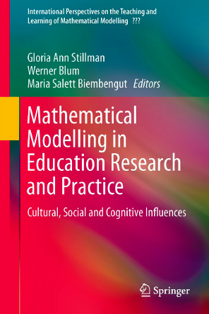

5.3 TSG at ICME 13
ICME-13 brings together researchers, teacher educators, practising teachers, mathematicians, and others interested in the field of mathematics education from all over the world to discuss the state of the art of research and practice in mathematics education. It will be held in Hamburg, Germany, from July 8-31, 2016 at the Congress Center Hamburg near Dammtor Station, and the University of Hamburg’s main building and campus. The congress is held every four years under the auspices of ICMI (International Commission on Mathematical Instruction).
TSG21 at ICME 13 will focus on Mathematical Applications and Modelling in the Teaching and Learning of Mathematics. The TSG will function as a Mini-Symposium, which displays the state-of-the-art-discussion bringing in renowned experts and allowing new scholars to enter the scene. An Essentials brief will be published before the conference to set the scene for the discussion. After the conference, the co-chairs will be seeking a special issue of a journal for a selection of the papers. The co-chairs are:
Gloria Stillman (Australian Catholic University, Australia), email: gloria.stillman@ac.edu.au
Jussara Araújo (Federal University of Minas Gerais, Brazil), email: jussara@mat.ufmg.br
The team members are:
Toshikazu Ikeda (Yokohama National University, Japan), email: toshi@ynu.ac.jp
Morten Blomhøj (Roskilde University, Denmark), email: blomhoej@ruc.dk
The team member from the German speaking countries is:
Dominik Leiss (Leuphana University Lüneburg, Germany), email: leiss@leuphana.de
IPC liaison person: Georg Ekol (Kyambogo University, Uganda), email: gle1@sfu.ca
The TSG invites papers to be submitted via Conftool in the period 1 September to 1 October. Papers must not exceed 4 pages and must use the required template. From the papers submitted, the co-chairs and team members will select around 8 papers to be presented at the regular sessions of the TSG. The authors of these papers will then be notified by 22nd December of the possibility to extend the paper; the extended paper is then due 28th February 2016. There will be an informal review on the quality of the extended papers until the 31st March 2016, with a chance to revise. All final papers should be submitted to ICME-13 (assistance.icme13@uni-hamburg.de) by 1st May 2016.
All papers evaluated positively will be uploaded to a protected part of the ICME website especially assigned to the TSG. ICME-13 follows the principle that papers or posters will only be rejected when they are not dealing with mathematics education or violating ethical issues. Based on this principle ICME-13 will be inclusive. Papers not accepted for presentation in TSG regular sessions can be presented as oral contributions associated with each TSG but programmed outside TSG regular timeslots. Please visit our TSG on the ICME 13 website at www.icme13.org for updates.

6. Recent Dissertations

Omobude, E. O. (2014). Learning mathematics through mathematical modelling: a study of secondary school students in Nigeria. Masters Thesis. Agder University, Norway
The focus of this study was to investigate the impact that mathematical modelling activities may have in the learning process of mathematics amongst Nigerian secondary school students. Additionally, the ways mathematical modelling activities might help these Nigerian secondary school students see the relevance of mathematics to real life were examined. From a pedagogical perspective, it was examined whether the application of modelling in the learning process of mathematics might be a vehicle for the enhancement and support of students' learning of mathematics. To begin, some past and present educational systems in Nigeria were explored to enable readers to gain an overview of these Nigerian educational systems. Data collection for the thesis proper involved ten senior secondary students from one public (government funded) senior secondary schools in Lagos, Nigeria. At the beginning, ten mathematical modelling problems were designed by the researcher for the students who were to be observed. Before the students started working with the tasks, the researcher interviewed them to obtain their opinions about (1) mathematics as a subject, (2) the way they were currently learning mathematics and (3) the connection between the mathematics they were learning in the classroom and the real life use of mathematics outside their classrooms. This pre-interview session was followed by some engagement of the observed students with the ten modelling problems although the researcher solved two of the problems for the students as examples. This process lasted three days. In the end, the same group of students were interviewed again so as to obtain their feedback/opinions about the modelling activities they undertook. The emphasis was to check the impact these modelling activities had on the students’ learning process. In Nigeria, secondary school students are taught mathematics in an authoritarian and traditional way. By this, it is meant a teacher-centred and lecture-based learning approach that only emphasizes the solving of exercises that must lead to correct answers. The consequence is that students are rarely shown or asked to link any mathematical problem to real life situations (modelling). This impression results from personal experience of the researcher at different stages of the Nigerian secondary school mathematics education system. In an effort to investigate the students’ learning process in mathematics and perhaps increase their interest in the discipline, alternative learning approaches that might offer different experience to students, may be introduced. This study follows this basis within the framework of Nigerian secondary school.
Scott-Wilson, R. (2014). An Analysis of Learning Characteristics, Processes, and Representations In Mathematical Modelling of Middle School Learners with Special Educational Needs. Doctor of Philosophy thesis, Stellenbosch University, Supervisor: DCJ Wessels. Joint-supervisors: E Swart, HM Wessels.
Mathematical modelling with special needs learners is an underdeveloped field of practice and research. This study describes how special needs learners engage with modelling practices by considering how modelling curricular activities for them could be designed so that student learning is optimised. The concepts of what special needs learners need from a teaching and learning environment, and what mathematical modelling could offer special needs learners were sourced from existing literature. Feuerstein’s work on structural cognitive modifiability was incorporated into the mathematical modelling tasks. In this regard, the need to mediate modelling tasks to develop underlying cognitive functions formed a framework for the approach. A class of special needs learners were introduced to mathematical modelling tasks. Their characteristics were analysed and the design of the tasks was adapted accordingly. In addition, their cognitive functions were evaluated and mediated and their mathematical representations were considered for evidence of learning. Furthermore, individual learner’s progression in modelling was correlated to their functional brain maps. The methodology followed the principles of design research together with a multiple case study approach on the progression of specific participants. How special needs learners interacted with the modelling tasks was documented through a qualitative analysis of the data. It was established that there is evidence to support the contention that special needs learners develop mathematical concepts through mediation over a month of engaging in daily modelling tasks. On the whole, the study contributes to understanding how special needs learners engage with modelling tasks and how modelling tasks may need to be adapted to support their learning in accordance with their individual characteristics, and their use of cognitive processes in light of their mathematical representations.
Wijaja, A. (2015). Context-based mathematics in tasks in Indonesia: Toward better practice and achievement. Doctor of Philosophy. Supervisors M. van den Heuvel-Panhuizen & L. Doorman. Utrecht University, The Netherlands.
The Indonesian national curriculum emphasizes that mathematics education must be relevant to the needs of life and should offer students opportunities to develop the ability to apply their knowledge in society. Furthermore, there are educational movements in Indonesia that emphasize the application of mathematics and promote the use of context-based tasks, i.e., Pendidikan Matematika Realistik Indonesia (Indonesian Realistic Mathematics Education) and Pembelajaran Kontekstual (Contextual Teaching and Learning). Nevertheless, the results of PISA studies showed that Indonesian students have poor performance on context-based tasks. Considering this situation, this PhD research was carried out to gain a better insight into Indonesian students’ low performance on context-based mathematics tasks and to generate recommendations for improving student performance.
The PhD research addresses three main research questions:
- What difficulties do Indonesian students have when solving context-based tasks?
- What are possible reasons for Indonesian students’ difficulties when solving context-based tasks?
- How can Indonesian student performance on context-based tasks be improved?
Four studies were carried out to answer these research questions.
The first study described Indonesian students’ difficulties when solving context-based tasks. Context-based PISA mathematics tasks were used in the study. Error analysis revealed that the most dominant errors were comprehension and transformation errors. This indicates that Indonesian students have difficulty mostly with the first two stages of solving context-based tasks. With respect to the first stage it was found that the students mainly made errors in selecting relevant information; whereas for the second stage the students were mostly unable to select the procedures that are suitable to solve the tasks.
The second study reports the opportunity-to-learn offered in Indonesian mathematics textbooks. Three mathematics textbooks that were used in the schools participating in the first study were analyzed. The analysis revealed that these books had a very low number of context-based tasks (only 10%). Three-quarters of these context-based tasks used a camouflage context and provided an explicit indication about the mathematical procedure to be used. This finding shows that these Indonesian mathematics textbooks do not offer students enough opportunity-to-learn to identify a suitable mathematical procedure to solve a context-based task, which might explain the high number of transformation errors made by the students. Moreover, most of the context-based tasks in these textbooks provided just precisely the information needed to solve a task. This result signifies a lack of opportunity for students to learn to select relevant information, which, therefore might have contributed to students’ comprehension errors, in particular errors in selecting information.
The third study focused on investigating the opportunity-to-learn to solve context-based tasks offered by the teachers’ teaching practice. The teachers tended to perceive context-based tasks merely as plain word problems. They believed that the mathematical procedure needed to solve a context-based task should be given explicitly. The teachers also did not consider missing and superfluous information as an important characteristic of a context-based task. In agreement with their beliefs, the teachers stated that they frequently offered their students context-based tasks with explicit procedures and that they rarely provided superfluous or missing information. Such practice might explain the students’ difficulties in identifying a suitable procedure and in selecting relevant information. Classroom observation showed that the teachers mainly used a directive teaching approach in which they told the students what a context-based task is about, translated the task into a mathematical problem, and explained what mathematical procedure had to be carried out. Students were not encouraged to be actively involved in and reflect on the process of solving context-based tasks. This directive teaching approach was mostly used in the comprehension and transformation stages. Consultative teaching in which students were actively engaged in the process of solving context-based tasks was barely used by the teachers. This consultative approach was mostly used in the mathematical processing stage.
The fourth study used the findings of the first three studies to develop an intervention intended to offer students opportunity-to-learn to solve context-based tasks. This intervention consisted of a set of context-based tasks and guidelines for a consultative teaching approach including giving students metacognitive prompts. The context based tasks included relevant and essential context, superfluous or missing information and no explicit suggestions for a suitable mathematical procedure. Student performance was seen from the perspectives of students’ gain scores and students’ errors. There was only a small and marginally significant effect of the opportunity-to-learn on the students’ gain scores. However, the students could better understand the wording of a context-based task and had improved performance in selecting relevant information. No influence was found in general on performance in transforming a real-world problem into a mathematical problem and in identifying a suitable mathematical procedure. However, a positive influence was found for context-based tasks addressing graphs, the topic taught during the intervention period. Students who were involved in the intervention were better able to give a mathematical interpretation of graphs. This finding indicates that to improve students’ ability to identify a suitable mathematical procedure it is important to provide students with context-based tasks that address all kinds of topics and not offer them context-based tasks that are only related to the current topic being taught, because that mathematical procedure is already identified.

7. Recent Publications of Interest
Akgün, L. (2015). Prospective mathematics teachers’ opinions about mathematical modeling method and applicability of this method. International Journal of Progressive Education, 11(2), 57-75.
Alsina, C. (2015). On hands-on material and real-world context. In G. Kaiser & H-W Henn (Eds.), Werner Blum und seine Beiträge zum Modellieren im Mathematikunterricht: Realitätsbezüge im Mathematikunterricht. (pp. 43-48). Fachmedien Wiesbaden: Springer Spektrum.
Ang, K.C. (2015). Mathematical modelling in Singapore schools: A framework for instruction. In N.H. Lee & K.E.D. Ng (Eds.), Mathematical modelling: From theory to practice (pp. 57-72). Singapore: World Scientific.
Anhalt, C. O., & Cortez, R. (in press). Developing understanding of mathematical modelling in secondary teacher preparation. Journal of Mathematics Teacher Education. DOI 10.1007/s10857-015-9309-8
Anhalt, C. O., & Cortez, R. (2015). Mathematical modelling: A structured process. Mathematics Teacher, 108(6), 446-452.
Ärlebäck, J.B., & Doerr, H.M. (2015).At the core of modelling: connecting, coordinating and integrating models. Paper presented at Working Group 6: Modelling and Applications at CERME 9 (Ninth Congress of European Research in Mathematics Education) Available from: http://www.cerme9.org/products/wg6/
Baron, L. M. (2015). An authentic task that models quadratics. Mathematics Teaching in the Middle School, 29(6), 335-340.
Barquero, B., Bosch, M., & Romo, A. (2015). A study and research path on mathematical modelling for teacher education. Paper presented at Working Group 6: Modelling and Applications at CERME 9 (Ninth Congress of European Research in Mathematics Education) Available from: http://www.cerme9.org/products/wg6/
Biembengut, M.S. (2015). Mathematical modelling, problem solving, project & ethnomathematics: confluent points. Paper presented at Working Group 6: Modelling and Applications at CERME 9 (Ninth Congress of European Research in Mathematics Education) Available from: http://www.cerme9.org/products/wg6/
Blum, W. (2015). Quality teaching of mathematical modelling: What do we know, what can we do? In S.J. Cho (Ed.), The Proceedings of the 12th International Congress on Mathematical Education (pp. 73-96). Cham: Springer.
Bloom, M., Fuentes, S.Q., Holden, M., & Feille, K. (2015). Navigating the environmental politics of energy production: Using mathematical modeling as a tool for educating science teachers for sustainability. In S.K. Stratton, R. Hagevik, A. Feldman, & M. Bloom (Eds.), Educating science teachers for sustainability (pp. 275-294). Cham: Springer.
Bock, W., Bracke, M., & Kreckle, J. (2015). Taxonomy of modelling tasks. Paper presented at Working Group 6: Modelling and Applications at CERME 9 (Ninth Congress of European Research in Mathematics Education) Available from:http://www.cerme9.org/products/wg6/
Borromeo Ferri, R. (2015). Mathematical thinking styles in schools and across cultures. In S.J. Cho (Ed.), Selected Regular Lectures from the 12th International Congress on Mathematical Education (pp. 153-174). Cham: Springer.
Brown, R., Redmond, T., Sheehy, J., & Lang, D. (2015). Mathematical modelling—an example from an inter-school modelling challenge. In N.H. Lee & K.E.D. Ng (Eds.), Mathematical modelling: From theory to practice (pp. 143-160). Singapore: World Scientific.
Búa Ares, J.B., Blanco, T.F., Sestelo, R.F. (2015). Mathematization and modelling of physical phenomena: analysis of two proposals. Paper presented at Working Group 6: Modelling and Applications at CERME 9 (Ninth Congress of European Research in Mathematics Education) Available from: http://www.cerme9.org/products/wg6/
Burke, J., Jablonka, E., & Olley, C. (2014). Mathematical modelling: Providing valid description or lost in translation. In P. Barnby (Ed.), Proceedings of the British Society for Research into Learning Mathematics 34.1 (pp. 31-46). Durham, UK: BSRLM.
Cabassut , R., & Ferrando, I. (2015). Conceptions in France about mathematical modelling: exploratory research with design of semi-structured interviews. Paper presented at Working Group 6: Modelling and Applications at CERME 9 (Ninth Congress of European Research in Mathematics Education) Available from: http://www.cerme9.org/products/wg6/
Carreira, S., & Baioa, A.M. (2015). Assessing the best staircase: students’ modelling based on experimentation with real objects. Paper presented at Working Group 6: Modelling and Applications at CERME 9 (Ninth Congress of European Research in Mathematics Education) Available from: http://www.cerme9.org/products/wg6/
Chan, C. M. E., Ng, K. E. D., Widjaja, W., & Seto, C. (2015). A case study on developing a teacher’s capacity in mathematical modelling. The Mathematics Educators, 16(1), 1-31.
Czocher, J.A. (2015). Competing conceptual systems and their impact on generating mathematical models. Paper presented at Working Group 6: Modelling and Applications at CERME 9 (Ninth Congress of European Research in Mathematics Education) Available from:http://www.cerme9.org/products/wg6/
Dewolf, T., Van Dooren, W., Ev Cimen, E., & Verschaffel, L. (2014). The impact of illustrations and warnings on solving mathematical word problems realistically. The Journal of Experimental Education, 82(1), 103-120.
Didi, S., & Tia, P. (2014). An analysis of difficulties on mathematical model interpretation of junior high school students on the materials of two-variable linear equation system. Proceedings of International Conference on Research, Implementation and Education of Mathematics and Sciences (ME-583- ME-588, Yogyakarta State University.
Djepaxhija, B., Vos, P., & Fuglestad, A.B. (2015). Exploring grade 9 students’ assumption making when mathematizing. Paper presented at Working Group 6: Modelling and Applications at CERME 9 (Ninth Congress of European Research in Mathematics Education) Available from:http://www.cerme9.org/products/wg6/
Doerr, H.M., & Ärlebäck, J.B. (2015). Fostering students’ independence in modelling activities. Paper presented at Working Group 6: Modelling and Applications at CERME 9 (Ninth Congress of European Research in Mathematics Education) Available from: http://www.cerme9.org/products/wg6/
English, L. (2015). Learning from modelling in the primary years. In N.H. Lee & K.E.D. Ng (Eds.), Mathematical modelling: From theory to practice (pp. 99-124). Singapore: World Scientific.
Eraslana, A., & Kant, S. (2015). Modelling processes of 4th-year middle-school students and the difficulties encountered. Educational Sciences: Theory & Practice, 15(3), 809-824.
Erbaș, A. K., Kertil, M., Çetìnńkaya, B., Çakiroğlu, E., Alacaci, C., & Bas, S. (2014). Mathematical modeling in mathematics education: Basic concepts and approaches. Educational Sciences: Theory & Practice, 14(4), 1621-1627.
Fernández-Plaza, J. A., Luis Rico, L., & Ruiz-Hidalgo, J. F. (2015). One-sided limits of a function at a point as explained by students in non-compulsory education in a drug metabolism context. Paper presented at Working Group 6: Modelling and Applications at CERME 9 (Ninth Congress of European Research in Mathematics Education) Available from: http://www.cerme9.org/products/wg6/
Galbraith, P. (2015). ‘Noticing’ in the practice of modelling as real world problem solving. In G. Kaiser & H-W Henn (Eds.), Werner Blum und seine Beiträge zum Modellieren im Mathematikunterricht: Realitätsbezüge im Mathematikunterricht. (pp. 151 – 166). Fachmedien Wiesbaden: Springer.
Gatabi, A. R., & M(2015). Ethnomathematics: An opportunity for designing authentic modelling problems. Paper presented at Working Group 6: Modelling and Applications at CERME 9 (Ninth Congress of European Research in Mathematics Education) Available from:http://www.cerme9.org/products/wg6/
Geiger, V. (2015). Mathemtical modelling in Australia. In N.H. Lee & K.E.D. Ng (Eds.), Mathematical modelling: From theory to practice (pp. 143-160). Singapore: World Scientific.
Gosh, J.B. (2015). Learning mathematics in secondary school: The case of mathematical modelling enabled by technology. In S.J. Cho (Ed.), Selected Regular Lectures from the 12th International Congress on Mathematical Education (pp. 203-222). Cham: Springer.
Guerrero-Ortiz, C., & Mena-Lorca, J. (2015). A comparison between mathematician and mathematics teachers’ strategies. Paper presented at Working Group 6: Modelling and Applications at CERME 9 (Ninth Congress of European Research in Mathematics Education) Available from: http://www.cerme9.org/products/wg6/
Große, C. S. (2014). Learning to solve story problems-supporting transitions between reality and mathematics. European Journal of Psychology of Education, 29(4), 619-634.
Hansen, R., & Hana, G.M. (2015). Problem posing from a modelling perspective. In F.M. Singer, N.F. Ellerton, & J. Cai (Eds.), Mathematical problem posing: From research to effective practice (pp. 35-46). New York: Springer.
Ikeda, T. (2015). Mathematical modelling in Japan. In N.H. Lee & K.E.D. Ng (Eds.), Mathematical modelling: From theory to practice (pp. 83-96). Singapore: World Scientific.
Jessen, B.E., Kjeldsen, T. H., & Winslφw, C. (2015). Modelling: From theory to practice. Paper presented at Working Group 6: Modelling and Applications at CERME 9 (Ninth Congress of European Research in Mathematics Education) Available from: http://www.cerme9.org/products/wg6/
Johnson, P., & Moylett, S. (2015). Evaluating the effectiveness of a framework for measuring students’ engagement with problem solving episodes. Paper presented at Working Group 6: Modelling and Applications at CERME 9 (Ninth Congress of European Research in Mathematics Education) Available from: http://www.cerme9.org/products/wg6/
Kazima, M. (2015). Students' reasons for preferences of contexts in learning mathematics. Paper presented at Working Group 8: Affect and Mathematical Thinking at CERME 9 (Ninth Congress of European Research in Mathematics Education) Available from: http://www.cerme9.org/products/wg8/
Kaiser, G., & Grünewald, S. (2015). Promotion of mathematical modelling competencies in the context of modelling projects.In N.H. Lee & K.E.D. Ng (Eds.), Mathematical modelling: From theory to practice (pp. 21-39). Singapore: World Scientific.
Lee, N. H., & K.E.D. Ng, K.E.D. (Eds.). (2015). Mathematical modelling: From theory to practice (pp. 125-141). Singapore: World Scientific.
Lingefjärd, T., & Farahani, D. (2015) Student’s interpretations of visual and symbolic models. Paper presented at Working Group 6: Modelling and Applications at CERME 9 (Ninth Congress of European Research in Mathematics Education) Available from: http://www.cerme9.org/products/wg6/
López, J. A.J., Ignjatov, J.S., Hernández Rebollar, L.A., & Kuhn, M. (2015). Differences in situation model construction for a historical problem: the broken tree or the broken bamboo? Paper presented at Working Group 6: Modelling and Applications at CERME 9 (Ninth Congress of European Research in Mathematics Education) Available from: http://www.cerme9.org/products/wg6/
Malkevitch, J. (2015). Modelling for introducing students to new tools. In G. Kaiser & H-W Henn (Eds.), Werner Blum und seine Beiträge zum Modellieren im Mathematikunterricht: Realitätsbezüge im Mathematikunterricht. (pp. 249-258). Fachmedien Wiesbaden: Springer Spektrum.
Martinez-Luaces, V. (2015). Mathematical models for chemistry and biochemistry service courses. Paper presented at Working Group 6: Modelling and Applications at CERME 9 (Ninth Congress of European Research in Mathematics Education) Available from: http://www.cerme9.org/products/wg6/
Ng, K.E. D., Widjaja, W., Chan, C.M.E., & Seto, C. (2015). Developing teacher competencies through videos for facilitation of mathematical modeling in Singapore primary schools. In S.F. Ng (Ed.), Cases of mathematics professional development in East Asian countries (pp. 15-38). Singapore: Springer. DOI 10.1007/978-981-287-405-4_3
OECD (2014). PISA 2012 Results: What Students Know and Can do: Student Performance in Mathematics, Reading and Science (Volume I) [Revised edition February 2014]. Paris: OECD.
Olley, C. (2015). School mathematical modelling: developing maths or developing modelling? Paper presented at Working Group 6: Modelling and Applications at CERME 9 (Ninth Congress of European Research in Mathematics Education) Available from: http://www.cerme9.org/products/wg6/
Peled, I., & Keisar, E. (2015). Emergence of tables as first-graders cope with modelling tasks. International Journal of Mathematical Education in Science and Technology, DOI: 10.1080/0020739X.2015.1005701
Reit, X-R., & Ludwig, M. (2015).Thought structures as an instrument to determine the degree of difficulty of modelling tasks. Paper presented at Working Group 6: Modelling and Applications at CERME 9 (Ninth Congress of European Research in Mathematics Education) Available from: http://www.cerme9.org/products/wg6/
Sala, G., Barquero, B., Vicenç Font, V., & Giménez, J. (2015). A multidisciplinary approach to model: some aspects of historical events. Paper presented at Working Group 6: Modelling and Applications at CERME 9 (Ninth Congress of European Research in Mathematics Education) Available from: http://www.cerme9.org/products/wg6/
Schukajlow, S., Krug, A., & Rakoczy, K. (2015). Effects of prompting multiple solutions for modelling problems on students’ performance. Educational Studies in Mathematics, 89(3), 393 - 417.
Schukajlow, S., Kolter, J., & Blum, W. (in press). Scaffolding mathematical modeling with a solution plan. ZDM Mathematics Education. DOI: 10.1007/s11858-015-0707-2
Stacey, K. (2015). The international assessment of mathematical literacy: PISA 2012 framework and items. In S.J. Cho (Ed.), Selected Regular Lectures from the 12th International Congress on Mathematical Education (pp. 771-790). Cham: Springer.
Stacey, K. (2015). The real world and the mathematical world. In K. Stacey & R. Turner (Eds.), Assessing mathematical literacy (pp. 57-84). Cham. Switzerland: Springer International Publishing.
Stacey, K., & Turner, R. (Eds.). (2014). Assessing mathematical literacy: The PISA experience. Cham, Switzerland: Springer.
Stillman, G. (2015). Applications and modelling research in secondary classrooms: What have we learnt? In S.J. Cho (Ed.), Selected Regular Lectures from the 12th International Congress on Mathematical Education (pp. 791-806). Cham: Springer.
Stillman, G. (2015). Fostering mathematical modelling in secondary schools. In N.H. Lee & K.E.D. Ng (Eds.), Mathematical modelling: From theory to practice (pp. 125-142). Singapore: World Scientific.
Stillman, G. (2015). Problem finding and problem posing for mathematical modelling. In N.H. Lee & K.E.D. Ng (Eds.), Mathematical modelling: From theory to practice (pp. 41-56). Singapore: World Scientific.
Stillman, G., & Brown, P. (2014). Evidence of implemented anticipation in mathematizing by beginning modellers. Mathematics Education Research Journal, 26(4), 763-789.
Tan, L.S., & Ang, K.C. (In press). A school-based professional development programme for teachers of mathematical modeling in Singapore. Journal of Mathematics Teacher Education.
Turner, R., Blum, W., & Niss, M. (2015). Using competencies to explain mathematical item demand: A work in progress. In K. Stacey & R. Turner (Eds.), Assessing mathematical literacy (pp. 85-115). Cham. Switzerland: Springer International Publishing.
Wake, G. (2014). Making sense of and with mathematics: The interface between academic mathematics and mathematics in practice. Educational Studies in Mathematics, 86(2), 271-290.
Wake, G., Foster, C., & Swan, M. (2015). Understanding issues in teaching mathematical modelling: lessons from lesson study. Paper presented at Working Group 6: Modelling and Applications at CERME 9 (Ninth Congress of European Research in Mathematics Education) Available from: http://www.cerme9.org/products/wg6/
Weber, E., Tallman, M.A., & Middleton, J.A. (2015). Developing elementary teachers’ knowledge about functions and rate of change through modelling. Mathematical Thinking and Learning,17(1), 1-33.
Weerd, L. v. d, (2015). The link between the cognitive structure and modelling to improve mathematics education. Paper presented at Working Group 6: Modelling and Applications at CERME 9 (Ninth Congress of European Research in Mathematics Education) Available from: http://www.cerme9.org/products/wg6/
Wijaya, A. (2015). Context-based mathematics tasks in Indonesia: Toward better practice and achievement. Utrecht, The Netherlands: FIsme Scientific.
Wijaya, A., & van den Heuvel-Panhuizen, M., & Doorman, M. Identifying ways to improve student performance on context-based mathematics tasks. Paper presented at Working Group 6: Modelling and Applications at CERME 9 (Ninth Congress of European Research in Mathematics Education) Available from: http://www.cerme9.org/products/wg6/
Wijaya, M., van den Heuvel-Panhuizen, Doorman, M., & Robitzsch, A. (2014). Difficulties in solving context-based PISA mathematics tasks: An analysis of students’ errors. The Mathematics Enthusiast, 11(3), 555-584.
Wolfsberg, A. (2015). Limitations on textbook support for teaching mathematical modelling competency – an exploratory case study. Paper presented at Working Group 6: Modelling and Applications at CERME 9 (Ninth Congress of European Research in Mathematics Education) Available from: http://www.cerme9.org/products/wg6/
Winsløw, C., Barquero, B., De Vleeschouwer, M., & Hardy, N. (2014). An institutional approach to university mathematics education: from dual vector spaces to questioning the world. Research in Mathematics Education, 16(2), 95-111.

8. Problems
This new section of the Newsletter was suggested by participants in the business meeting at ICTMA 16 in Brazil. Other than the problems shared by Michael in the last Newsletter none have been received in the interim. If we are to continue this section, problems need to be contributed for members to work on. Please send problems to the editor for the next Newsletter. We have another contribution from Michael.
Teaching Mathematics or Mathematical Modelling? (An Answer to a Comment)
In the last issue of the ICTMA’s Newsletter (Vol. 7, No. 1, July 2014) and in the column of “Modelling Problems” (pp. 11-14) I have published an announcement entitled “Remarks on and Examples of Mathematical Modelling Problems”. At the end of my announcement it was written the following comment for Problem 1, which was included in it:
“In the workplace, any product with bends in it require more material to achieve the final design shape than a flat shape of the same size. The angle of the bend also contributes to this. The impact for producing one product is minimal, but when producing thousands the impact is significantly increased. Therefore, more material will be required”.
In other words, the author of the above comment, if I have understood it well, suggests a kind of problem-posing (e.g., see Brown and Walters, 1990), that is, starting from Problem 1 to create a series of similar problems by changing the angle of the bend, etc. Is it a useful comment? In first place of course it is! Such type of problem-posing can be used to challenge over-reliance on the instructor and the text book and give the students an improved sense of ownership and engagement in their education. Moreover, extending problems with problem-posing offers other potential benefits. As part of the critical “look back” process of problem-solving, it can enhance student reasoning and reflection needed for a deep understanding of mathematics. Also student-generated connections between mathematics and the real world often spring from such creative experiences (Voskoglou, 2011, p. 70).
However, as it was explained in my announcement, in this case Problems 1 and 2 were given to students when I was teaching the derivatives within the course “Higher Mathematics I” and I simply wanted to enrich my lecture with some real world applications. Imagine now the hypothetical scenario in which I would decide to apply the above suggestion in my lecture. I am sure that my students would turn their attention from derivatives rather to the effort of “playing” by creating as many similar problems, as they can!
In concluding, Mathematical Modelling (MM) appears today as a dynamic tool for teaching and learning mathematics, because it connects mathematics with our everyday life giving the possibility to students to understand its usefulness in practice and therefore increasing their interest about mathematics. In other words, according to the Polya’s (axioms of learning) terminology, MM works as a best motivation for learning mathematics. But we must be careful! The process of MM could not be considered as a general and therefore applicable in all cases method for teaching mathematics. In fact, such a consideration could lead to far-fetched situations, where more emphasis is given to the search of the proper application rather, than to the consolidation of the new mathematical knowledge!
M. Voskoglou
References
Brown, S. I., & Walters M. I. (1990), The art of problem posing, Laurence Erlbaum Associates, Hillsdale, NJ.
Polya , G. (1963), On learning, teaching and learning teaching, American Mathematical Monthly, 70, 605-619.
Voskoglou, M. Gr. (2011). Problem-solving from Polya to nowadays: A review and future perspectives. In R.V. Nata (Ed.), Progress in education, Vol. 22 (pp. 65-82). New York, NY: Nova Publishers

